Look like | Sound like
Feel like | Smell like
Taste like
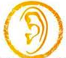
What does the celebration of the Eucharist……

